Artist Name: Sue Quinby
Artist's birthdate: 24/11/1979
Title: Hide & Sika
Year of Production: 2025;
Where signed & dated (Provide details of position of signature) Signed bottom right hand corner
Medium: Watercolour
Dimensions (of artwork itself not frame): 28cm x 78cm
Genre (eg. still life): Ladscape
Artwork type (eg.Painting): Painting
Framing details: 98 cm x 55cm
Provenance, Exhibitions (Optional) If an artwork has been in a major exhibition or won an award previously please provide details.
Your Retail price: £400

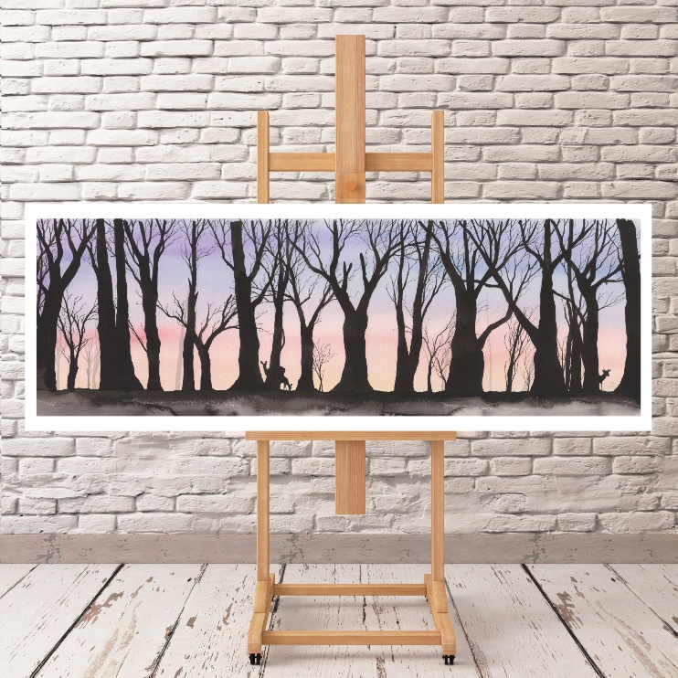

Hide & Sika is named playfully for the deer that is hiding and Sika which is a species of Uk deer. I like to have a bit of humour in my artwork and in naming them.

Artist Name: Sue Quinby
Artist's birthdate: 24/11/1979
Title: Fawntasia
Year of Production: 2025;
Where signed & dated (Provide details of position of signature) Signed bottom right hand corner
Medium: Watercolour
Dimensions (of artwork itself not frame): 28cm x 78cm
Genre (eg. still life): Ladscape
Artwork type (eg.Painting): Painting
Framing details: 98 cm x 55cm
Provenance, Exhibitions (Optional) If an artwork has been in a major exhibition or won an award previously please provide details.
Your Retail price: £400

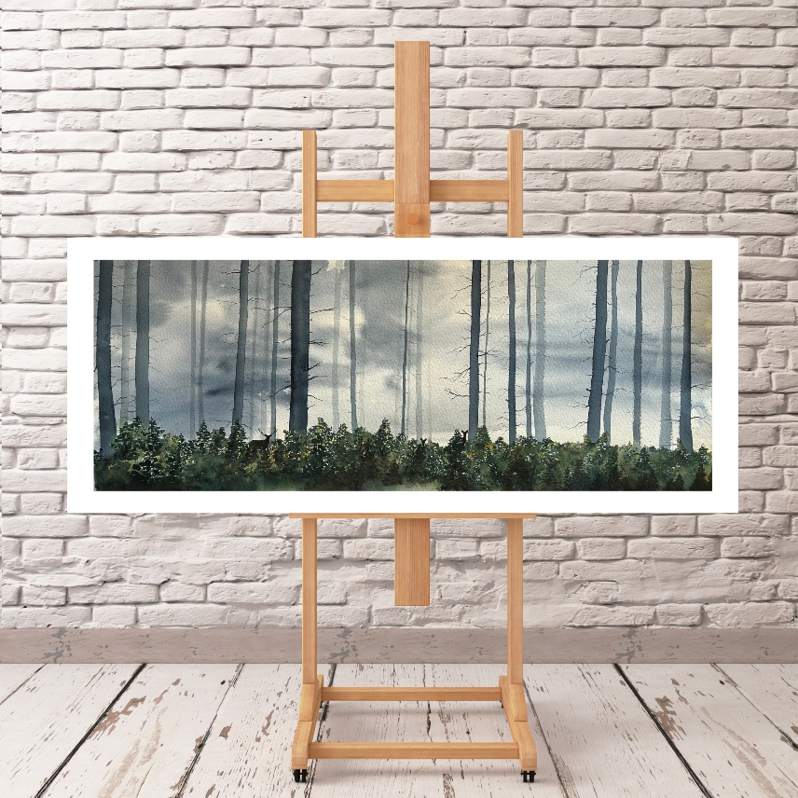
Fawntasia is a scene inspired by the beautiful trees of Snake Woods in the Peak District. The woodland there has a magical atmosphere.

Artist Name: Sue Quinby
Artist's birthdate: 24/11/1979
Title: Royal Roscoe
Year of Production: 2026
Where signed & dated (Provide details of position of signature) Signed bottom right hand corner
Medium: Watercolour
Dimensions (of artwork itself not frame): 30cm x 30cm
Genre (eg. still life): Ladscape
Artwork type (eg.Painting): Painting
Framing details: 40cm x 40cm
Provenance, Exhibitions (Optional) If an artwork has been in a major exhibition or won an award previously please provide details.
Your Retail price: £200

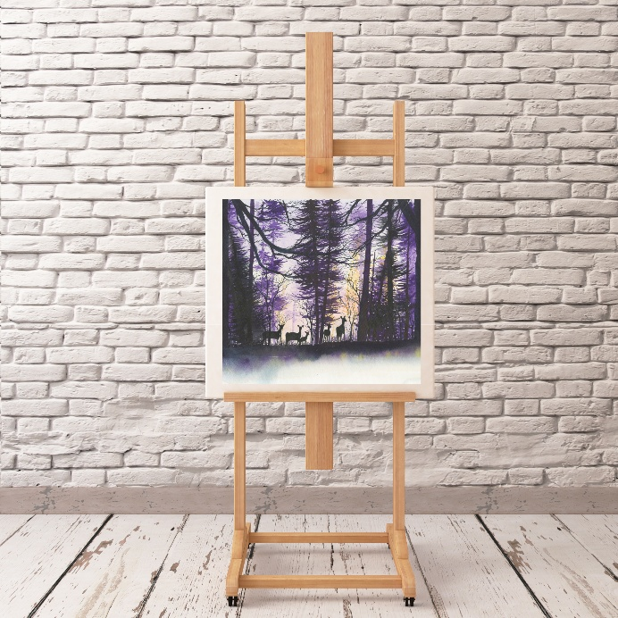

Royal Roscoe is so named due to the purple colour traditionally a royal colour and also as the term is for a stag with 12 point antlers. Roscoe is an old Norse word for Deer Forest.

Artist Name: Sue Quinby
Artist's birthdate: 24/11/1979
Title: Sadhbhs’ Santuary
Year of Production: 2026
Where signed & dated (Provide details of position of signature) Signed bottom right hand corner
Medium: Watercolour
Dimensions (of artwork itself not frame): 30cm x 30cm
Genre (eg. still life): Ladscape
Artwork type (eg.Painting): Painting
Framing details: 40cm x 40cm
Provenance, Exhibitions (Optional) If an artwork has been in a major exhibition or won an award previously please provide details.
Your Retail price: £200

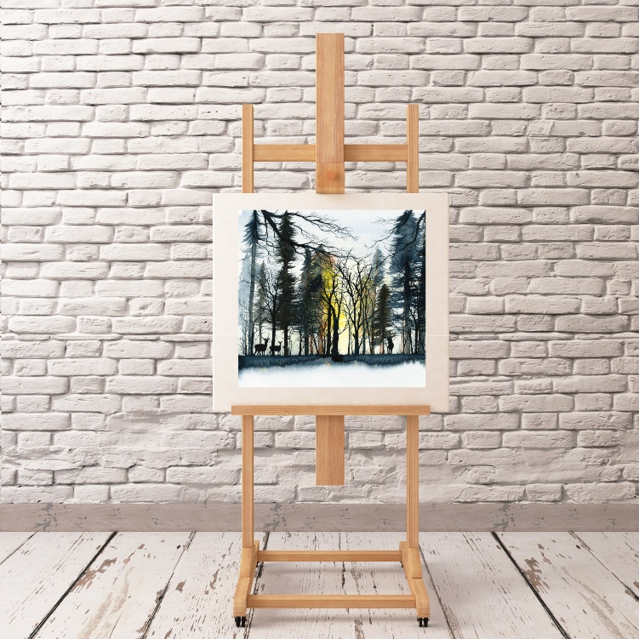
The meaning behind the title of this painting comes from Irish mythology. The legend goes that Sadhbh (pronounced sigh-ve) refused to marry the Dark Druid and as punishment she was enchanted to take the form of a doe. After 3 years she found out that the Dark Druid would have no power over her if she set foot in the castle. She travelled straight there and was found by Fionn while he was out hunting. Sadhbh became a beautiful girl once more and soon she and Fionn were married. Fionn loved her so much that he gave up hunting and all other pleasures but her.

Artist Name: Sue Quinby
Artist's birthdate: 24/11/1979
Title: Fiadh of the Forest
Year of Production: 2026
Where signed & dated (Provide details of position of signature) Signed bottom right hand corner
Medium: Watercolour
Dimensions (of artwork itself not frame): 30cm x 30cm
Genre (eg. still life): Ladscape
Artwork type (eg.Painting): Painting
Framing details: 40cm x 40cm
Provenance, Exhibitions (Optional) If an artwork has been in a major exhibition or won an award previously please provide details.
Your Retail price: £200

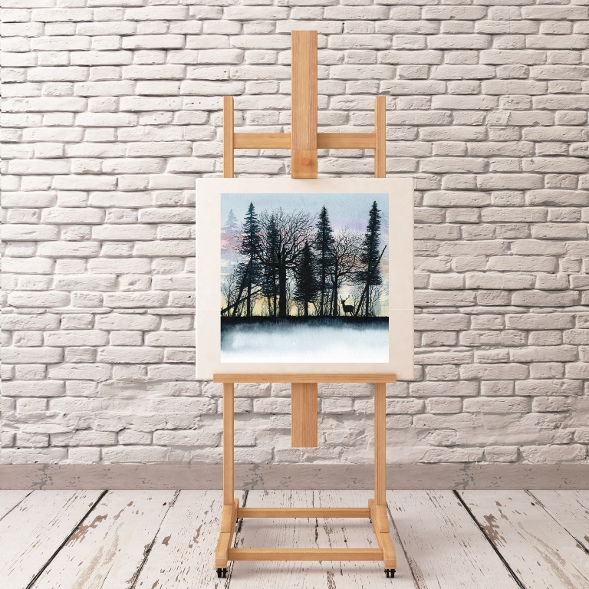

The meaning behind the title ‘Fiadh of the Forest’ comes from the old Irish word for deer - Fiadh. The word also has associations of ‘wild’ and in particular ‘natural beauty’, ‘grace’ and ‘untamed spirit’. All the things I associate with deer in a forest.

